Docker compose file writing

A Docker Compose file uses YAML syntax to define and run multi-container Docker applications. Here is a simple example with essential syntax and explanations for beginners.
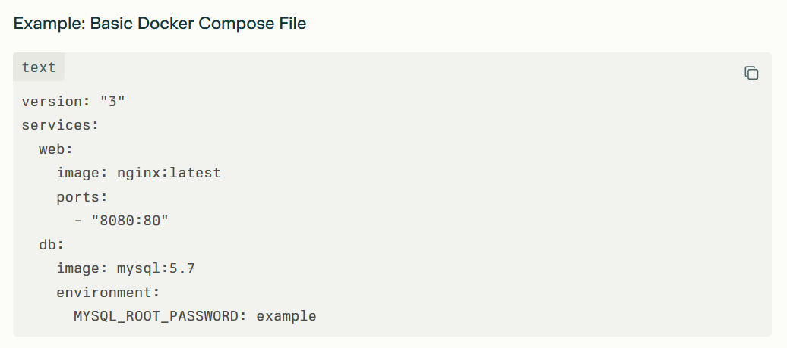

- version: "3"

In a Docker Compose file, version: "3" sets the format version for the compose file. This tells Docker Compose which features and syntax the file can use, and helps make sure your setup is compatible with your Docker installation.
For example, Compose file version 3 is optimized for using Docker Swarm and includes features that may not be available in earlier versions. While recent versions of Docker Compose may ignore the version line, it's good practice to include it for backward compatibility, especially if you are following tutorials or working with older setups

- Services
The services: section in a Docker Compose file is where each part of an application is defined as a separate service. Each service runs in its own container and is individually configured, for example as a web server, database, or cache.
Every service under services: is essentially a container with its own specific role in the application stack.
This section lets you specify the Docker image to use, environment variables, network settings, and volumes for each service, providing full control and flexibility for multi-container applications.
Services can communicate with each other using service names as hostnames, making it easy to connect components like a web server to a database.
In summary, the services: section organizes and manages all the containers needed for an application, ensuring they can operate together efficiently.

- Web :

In a Docker Compose file, the line web: defines the name of a service (container) within the services section. This is just a label or identifier and can be anything meaningful such as web, db, api, etc.
The name helps to reference the service within the Compose file and when using Docker commands, like checking logs or networking between services.
For example, in networking, other services can reach the container running this service using the name web as a hostname.
The service name does not affect the actual container name unless you explicitly set the container name property.
Choosing clear service names makes it easier to manage and understand multi-container applications.

- image: nginx:latest

The line image: nginx:latest in a Docker Compose file tells Docker to use the official Nginx image from Docker Hub to create the container. Here’s what it means for beginners:
image: specifies which pre-built Docker image to use for the container.
nginx is the name of the image for the popular web server.
latest refers to the most recent stable version of this image available on Docker Hub.
When you run Docker Compose, it will check if this image is available locally, and if not, it will download (pull) it from Docker Hub automatically.
Using the latest tag means you always get the latest version, but you can specify specific versions by changing the tag (e.g., nginx:1.23).
This lets you quickly spin up a ready-to-use Nginx web server container without building or configuring it yourself.

- ports:
In Docker Compose, the ports: section maps network ports between your computer (the host) and the running container.
The line "8080:80" means that port 8080 on your host machine is connected to port 80 inside the container.
Port 80 is the default port where the Nginx web server listens inside the container.
So, when you open a browser and visit localhost:8080, your request is forwarded to port 80 in the container, showing the Nginx welcome page running inside the container.
This mapping allows access to container services through custom ports on your host, enabling multiple services or containers to avoid port conflicts on the host.
Thus, port mapping is essential for exposing containerized applications to your local machine or external network.

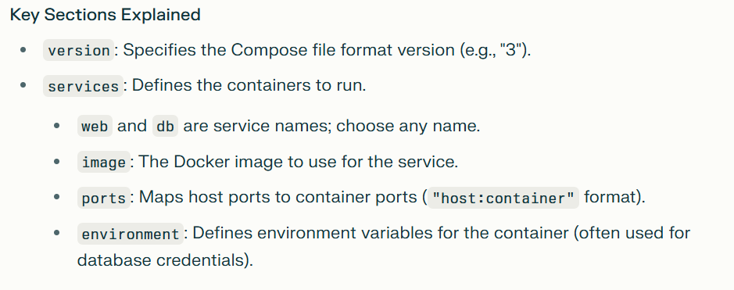

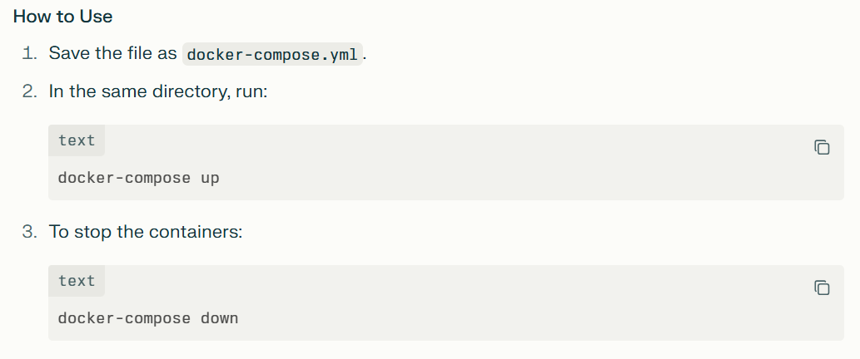

- What is Docker Compose and what is its primary use?
Docker Compose is a tool for defining and running multi-container Docker applications using a YAML file. It simplifies managing multiple containers by allowing configuration in a single file and running them with one command.

- How does Docker Compose help in managing multi-container Docker applications?
It lets you define all services, networks, and volumes in a single file, making it easy to start, stop, and configure multiple containers as a group.

- Explain the structure of a Docker Compose file.
The file is written in YAML format and includes sections like version, services (for container definitions), volumes (for data persistence), and networks (for container communication).
- What does the version field in a Docker Compose file signify?
It specifies the Compose file format version, which determines the available features and syntax compatibility with Docker Compose.

- How do you define and link multiple services in a Docker Compose file?
You list services under the services: section, each with its own configuration. Services can communicate by referencing other service names as hostnames.

- How do you perform port mapping in Docker Compose?
Using the ports: section, you specify host-to-container port mappings such as "8080:80", allowing access to container services via host ports.

- How can you specify environment variables in a Docker Compose file?
Use the environment: section under a service to define key-value pairs for variables inside the container.

- Can you define dependencies between services in Docker Compose? How?
Yes, with depends_on: you specify the order of service startup but it doesn’t wait for service readiness—only container start.

- What is the purpose of the networks section in Docker Compose?
It defines custom networks for services to communicate securely and isolate container traffic.

- How would you scale services using Docker Compose?
Use docker-compose up --scale servicename=num to run multiple instances of a service.

- How can you override settings defined in the docker-compose.yml file?
You can use multiple Compose files (e.g., docker-compose.override.yml) to override or add configuration selectively.

12 ) How can you use Docker Compose in a CI/CD pipeline?
Use Compose files to define test or deployment environments, then automate running containers for integration tests or app deployment in CI/CD workflows
Dockerfile to build MySQL database image:
FROM mysql:latest
ENV MYSQL_ROOT_PASSWORD=password
ENV MYSQL_DATABASE=mydb
ENV MYSQL_USER=user
ENV MYSQL_PASSWORD=userpassword
EXPOSE 3306

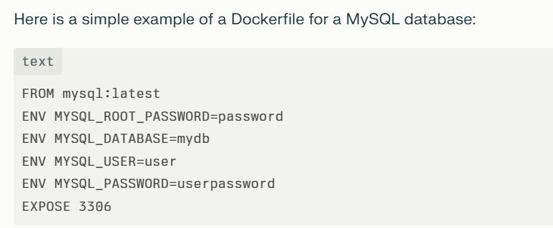

These commands are environment variable settings used to configure a MySQL database container in Docker:
ENV MYSQL_ROOT_PASSWORD=password: Sets the root user password for the MySQL server to "password". This is mandatory for the official MySQL image and secures the root account.
ENV MYSQL_DATABASE=mydb: Creates a new database named "mydb" automatically when the container starts for the first time.
ENV MYSQL_USER=user: Creates a new MySQL user account with the username "user" when the container initializes.
ENV MYSQL_PASSWORD=userpassword: Sets the password for the user account "user" created by the above variable.

To establish a connection between two Docker containers for hosting a two-tier application (e.g., web server and database), the best practice is to place both containers on the same Docker network. This allows the containers to communicate by referring to each other by container or service name.

In two ways ,we can establish the connection between multiple docker

- Using Docker user-defined bridge network:
Create a network:
docker network create my_network
Run containers on that network:
docker run -d --network my_network --name db_container mysql
docker run -d --network my_network --name web_container my-web-app
The web container can connect to the database using the hostname "db_container" on the relevant port.
2) Using Docker Compose for multi-container apps:

- Define services in a docker-compose.yml file.

- Docker Compose automatically creates a network and connects all services to it.
- Containers communicate using service names as hostnames.

Example minimal docker-compose.yml for two-tier app:

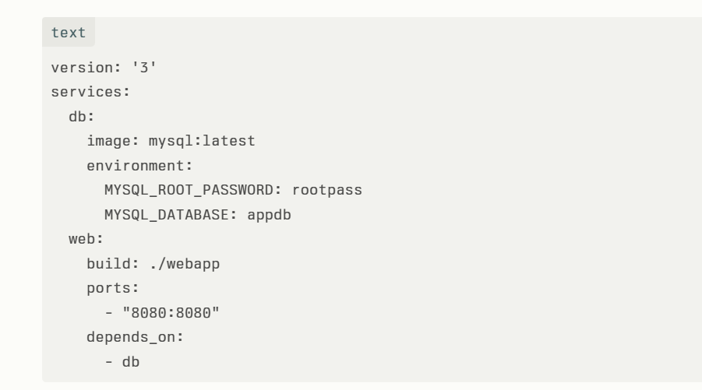

Explanation for few commands

- build: ./webapp

The build: ./webapp command in a Docker Compose file tells Docker Compose to build a Docker image for the service using the Dockerfile located in the ./webapp directory.
:
Here's what it means in detail
build specifies the context (folder) to use for the Docker build.
./webapp is a relative path to the folder containing the Dockerfile and source files needed to create the image for this service.
When you run docker-compose up or docker-compose build, Docker will look into the ./webapp directory, find the Dockerfile there, and use it to build a Docker image.
This image will then be used to create a container for that service.
In short, this command automates building a custom image for your service based on the Dockerfile and files in the specified path before running the container.

- depends_on

The depends_on key in a Docker Compose file specifies service dependencies and controls the order in which containers are started and stopped.
depends_on: - db means the service depends on the db service (usually a database).
Docker Compose will start the db service before starting the service that declares the dependency.
It ensures that the dependent service won't start until the services it depends on are at least started.

